Open Control Panel → Programs → Turn Windows features on or off
Enable:
✅ Virtual Machine Platform
✅ Windows Subsystem for Linux
✅ Hyper-V
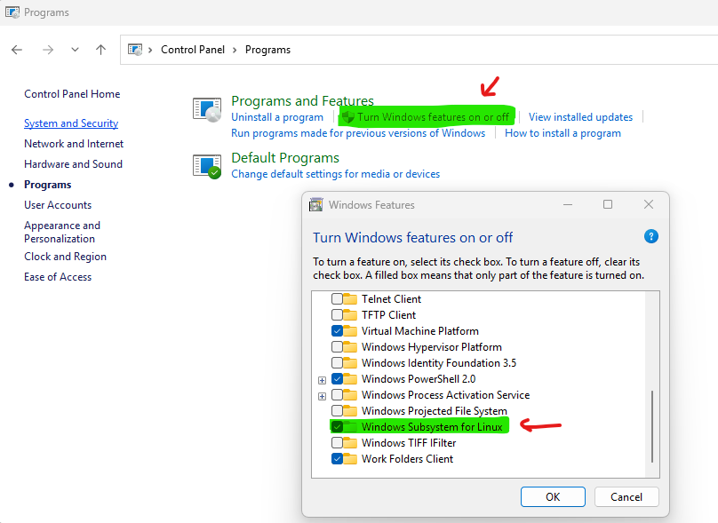

Install WSL 2
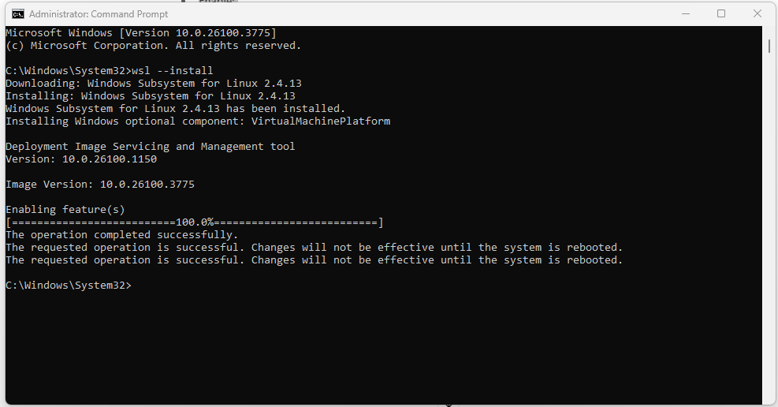

Install Docker (Windows AMD64 version) from:
https://www.docker.com/products/docker-desktop/
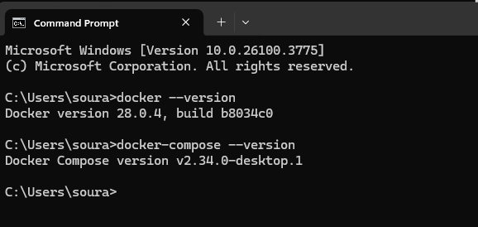
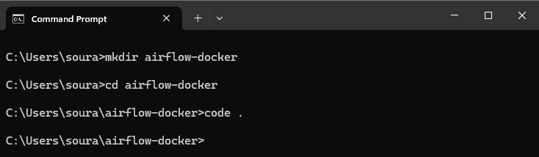

curl 'https://airflow.apache.org/docs/apache-airflow/2.8.1/docker-compose.yaml' -o 'docker-compose.yaml'

create a .env file in the same folder
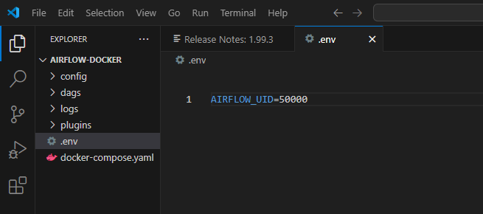

mkdir dags
mkdir logs
mkdir plugins
docker-compose up airflow-init
docker-compose up
==================================================================
- Web UI: http://localhost:8080
- Default credentials:
  - Username: airflow
  - Password: airflow
You can change credentials by editing docker-compose.yaml → AIRFLOW__CORE__FERNET_KEY, AIRFLOW__WEBSERVER__RBAC, etc.
==================================================================

Add your dag
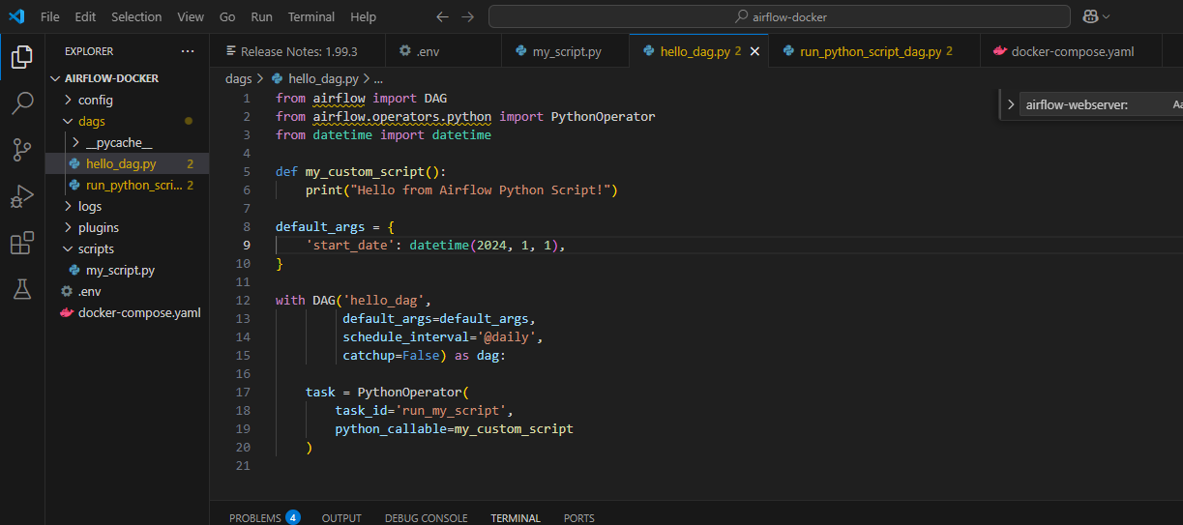

FOR running python script
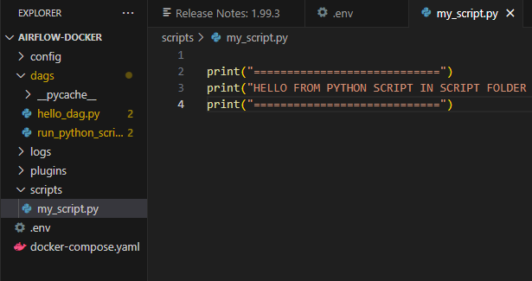

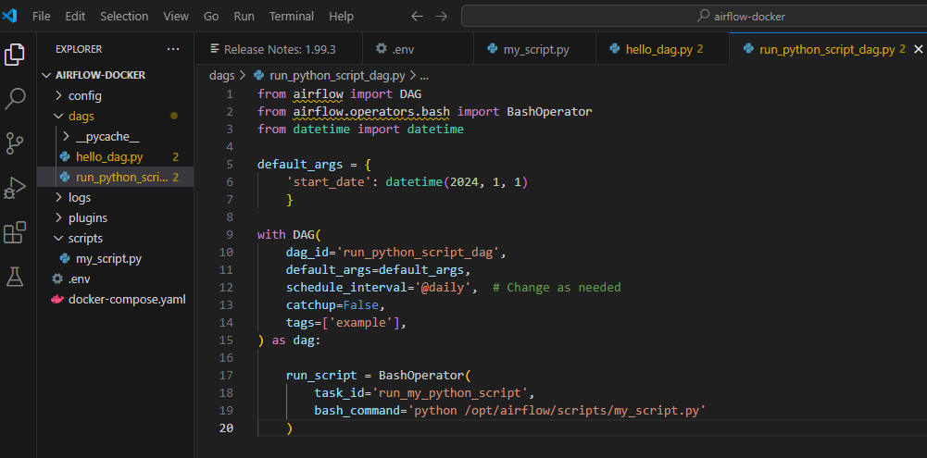

Ensure that the logs directory is mounted as a volume in all relevant Airflow services (webserver, scheduler, worker, etc.) within your docker-compose.yaml. This allows all services to access and write logs consistently.

volumes:
- ./dags:/opt/airflow/dags
- ./logs:/opt/airflow/logs
- ./scripts:/opt/airflow/scripts

